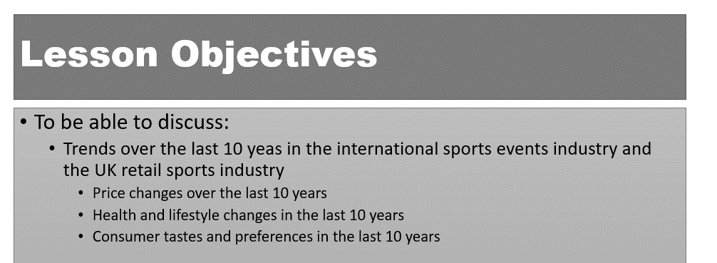

This lesson links to these units:

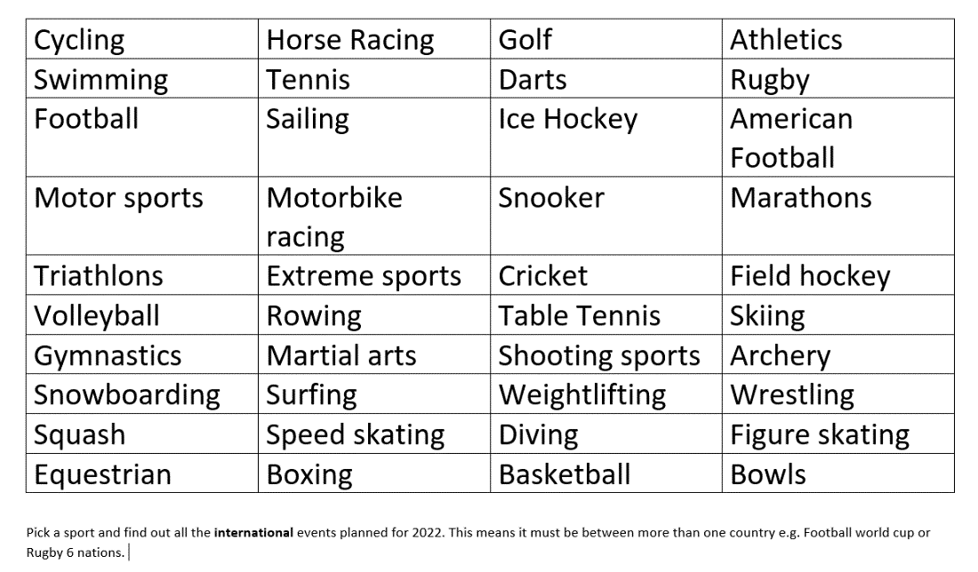

What is a trend?

- A trend is something that has changed over time and continues to be the norm
- E.g. smoking has been replaced by the trend in vaping and DVDs and CDs have been replaced by the trend in streaming
- In contrast a fad is a short-term spike in demand which returns to a different norm afterwards e.g. fidget toys, hover boards

Name 3 recently discontinued Olympic sports:
1
2
3

Link between price and profitability

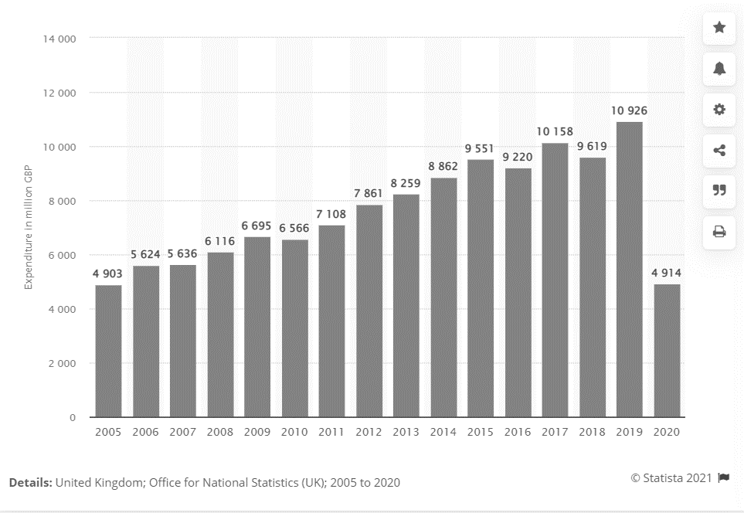

Draw 3 conclusions from the data:

1

2

3

Changing prices over last 10 years
(UK sports retail) Sports Direct
- Over the past decade, Sports Direct more than doubled its group revenue and grown its profits to £1.5 billion
- The company expanded during the Pandemic to take advantage of the athleisure wear trend

Athleisure is:

Changing prices over last 10 years
(UK sports retail) JD Sports
- JD Sports’ transformation from a sportswear retailer to a multi-brand company with high profile sports sponsorships has been dramatic
- Since 2020, the company’s annual group revenue reached £6 billion
- This is due to rapid expansion in the UK market, over the last decade

My 3 facts about JD Sports:
1
2
3

Changing prices over last 10 years in international sports events

Season tickets would not be on this list because…

Olympic Ticket prices in 2012

Olympic Ticket prices in 2021

Conclusions

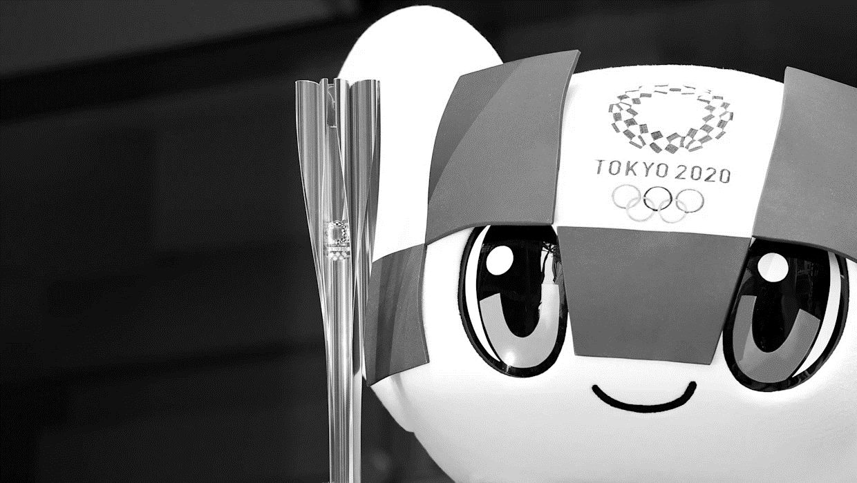

Travel to international sporting events

Trends in prices of travel to international sporting events

- Sports tourism is a rapidly expanding segment in the travel and tourism industry. In fact, it is the fastest growing segment of the travel industry today, generating millions of pounds each year
- Sports tourism is a growing trend that will expand in the coming years
- Prices of tourism packages have risen in line with inflation

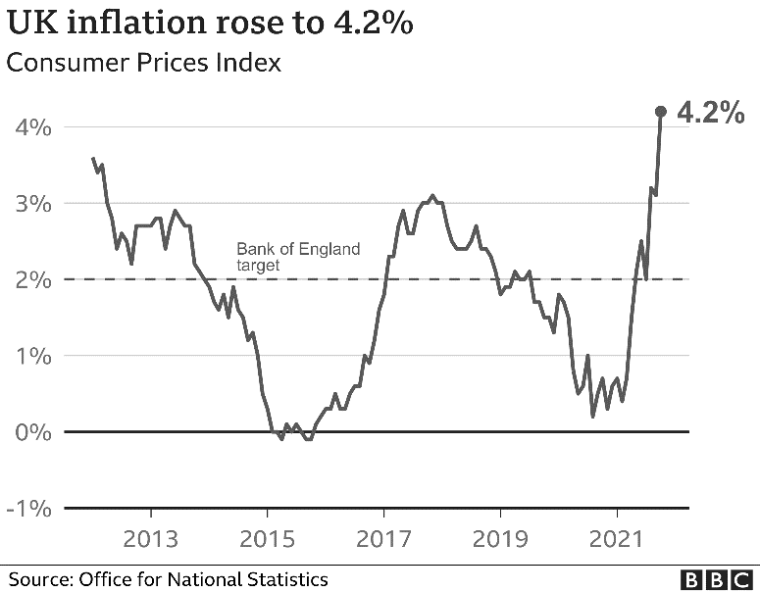

What is the current UK inflation rate?_______________________
Can you explain the term inflation rate?

Can you identify how a rise in inflation may impact the price of travel to international sporting events?

Can you identify the subsequent impact on demand?

Types of pricing strategy

#1 Cost-plus

- A cost-plus pricing strategy seeks to set a price for a product or service which covers the costs AND provides a good profit margin for the business
- Cost-plus may be found in the international sporting event ticket pricing strategy (see the very simplistic example on the right)

The Wimbledon 2022 men’s final ticket costs _________________

#2 Price skimming
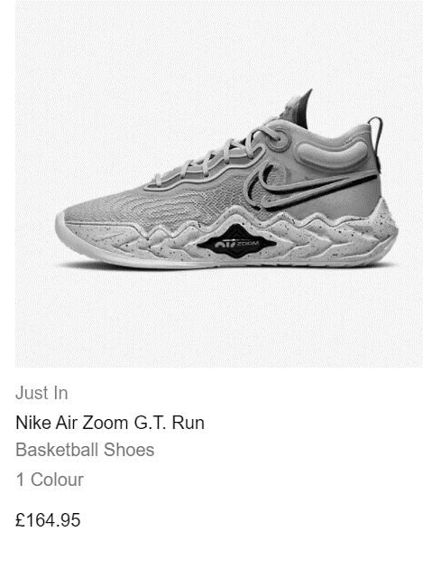

As trainers move along the product lifecycle….

#3 Penetration pricing

- This is the opposite to skimming and means setting prices low to encourage customers to try the products, as market share grows, the prices can be raised
- In mass markets this will encourage repeat purchase
- Critical for e-commerce stores starting up in the market, will break down barriers to entry

Why penetration pricing is a risky strategy for a sports retail business….

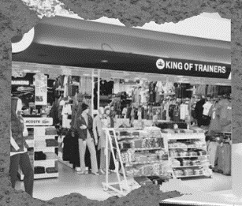

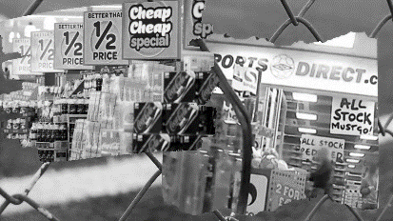
#4 Predatory pricing

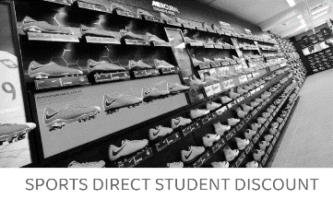
#5 Competitive pricing

Can you identify 3 other non-price ways that help customers to choose where to shop for their sporting goods?
1
2
3

#6 Psychological pricing

- This means pricing a product at £1.99 rather than £2.00 to appear ____________
- Some businesses consider pricing ______________ as it is often an indicator of quality
- However, it is an attention _______________________ if used in a promotion
- Do ticket agencies for major international sporting events use psychological pricing?

Differentiation
PED
Number of competitors
Strength of brand
Stage in the product life cycle
Costs

Trends in health and lifestyle in the last 10 years introduction

#1 Use of technology

#2 Emergence of the boutique gym
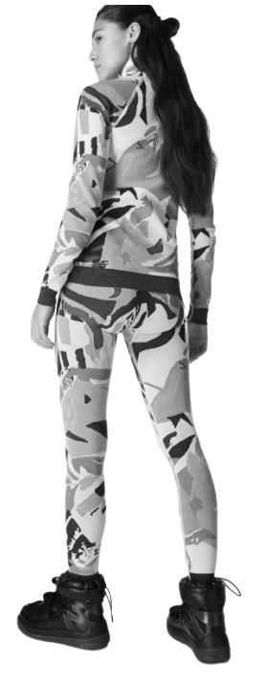
“Boutique gyms have clients, not members, and the personal touch, they say, secures more long-term results and more customer loyalty. Now going to the gym is a well-rounded experience, with body composition checks, personal training, smaller class sizes, luxury toiletries and, of course, shops filled with luxe gym wear.”

#2 Boutique gyms, which brought back group fitness classes

What impact will this have on market segmentation?

What impact will this have on the product ranges stocked by UK sports Retailers?

#3 Wellness and self-care
- The wellness and self care focus has been a rising trend for several years in the UK
- Sports retail companies like JD Sports work with mental health and homeless charities
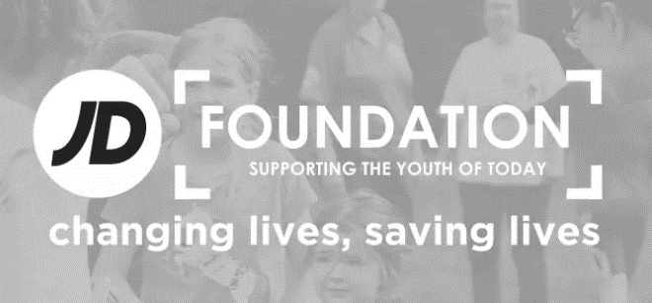

What will JD Sports gain from helping with this kind of charities?

Hello!
Thank you for trying this sample pack – if you buy the whole pack you will get the entire worksheet and PowerPoint.

