1 Google | 2 Shell | 3 Starbucks | 4 Doritos
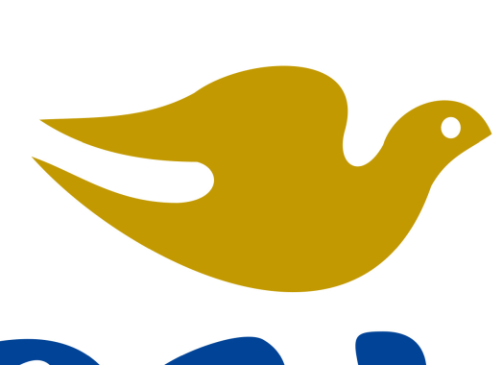
5 Dove | 6 Toyota | 7 Coco pops | 8 Champion
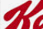 |  | 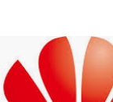
9 Kelloggs | 10 Samsung | 11 Huawei | 12 H&M
13 Hollister | 14 Vans | 15 Visa | 16 Apple Pay
Instructions
Write the name of the brand next to the number

Results:
16-14 Expert
13-9 Proficient
8-4 Advanced beginner
3-0 Novice

