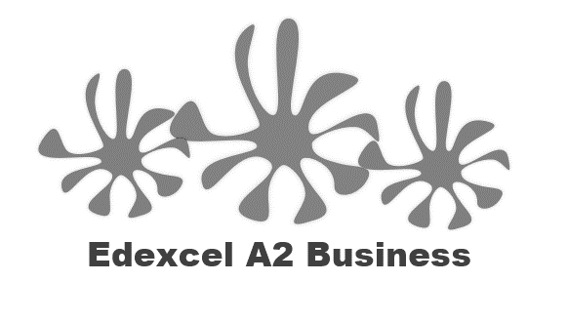
3.1.1 Understanding the nature and purpose of business

- Why businesses exist
  - Business objectives such as profit, growth, survival, cash flow, social and ethical objectives
- The relationship between mission and objectives
- Why businesses set objectives
- The measurement and importance of profit
  - Revenue
  - Fixed costs
  - Variable costs
  - Total costs

Starter – 3 quick questions

Definition: Business Objectives
________________________________________________________________________________________________________________________________________________________________________________________________________________________________________________________________________________________________________________________________________
S M A R T

Example of a smart objective
____________________________________________________________________________________________________________________________________________________________________
Business objective: Profit
________________________________________________________________________________________________________________________________________________________________________________________________________________________________________________________________________________________________________________________________________
Business objective: Profit maximisation
________________________________________________________________________________________________________________________________________________________________________________________________________________________________________________________________________________________________________________________________________
Business objective: growth
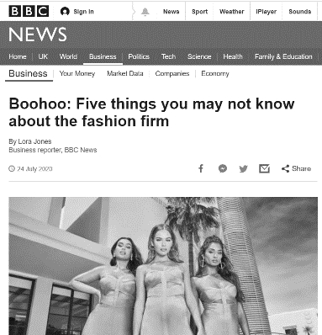

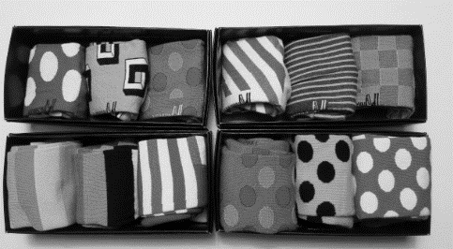
Business objective: Survival
________________________________________________________________________________________________________________________________________________________________________________________________________________________________________________________________________________________________________________________________________
Business objective: Cash-flow
________________________________________________________________________________________________________________________________________________________________________________________________________________________________________________________________________________________________________________________________________
Business objective: Social

________________________________________________________________________________________________________________________________________________________________________________________________________________________________________________________________________________________________________________________________________

Business objective: Social
________________________________________________________________________________________________________________________________________________________________________________________________________________________________________________________________________________________________________________________________________
Business objective: Social

________________________________________________________________________________________________________________________________________________________________________________________________________________________________________________________________________________________________________________________________________
Business objective: Ethical
________________________________________________________________________________________________________________________________________________________________________________________________________________________________________________________________________________________________________________________________________

Definition: Mission Statement
____________________________________________________________________________________________________________________________________________________________________
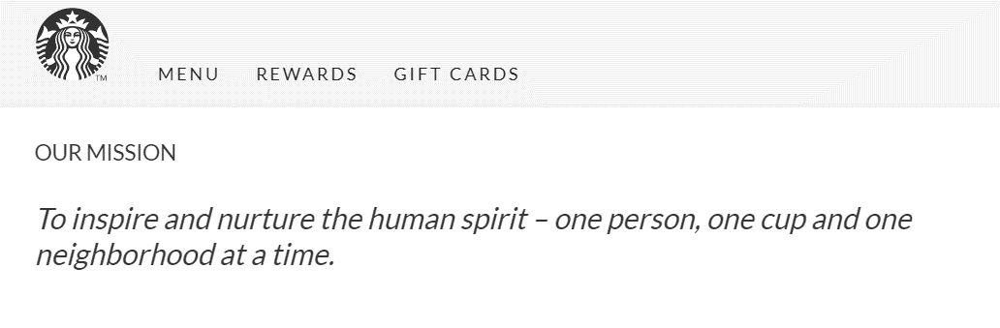
Mission and objectives

Mission and objectives (continued)
________________________________________________________________________________________________________________________________________________________________________________________________________________________________________________________________________________________________________________________________________
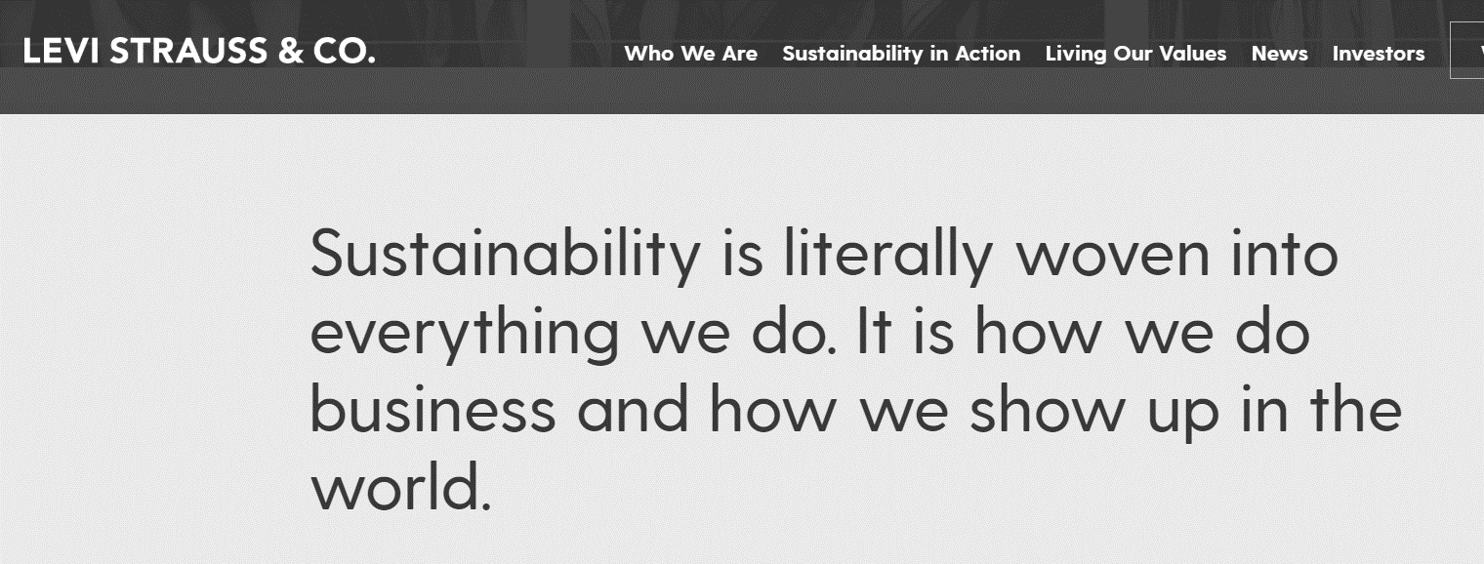
Why does a business set objectives?

Why does a business set objectives? (continued)

________________________________________________________________________________________________________________________________________________________________________________________________________________________________________________________________________________________________________________________________________
Definition: Profit

Total costs (TC)

Definition: Fixed Costs

________________________________________________________________________________________________________________________________________________________________________________________________________________________________________________________________________________________________________________________________________
___________________________________________________________________

Examples of Fixed Costs (FC)

Calculating fixed costs, write the formula in here:

Try the example:

Definition: Variable Costs
________________________________________________________________________________________________________________________________________________________________________________________________________________________________________________________________________________________________________________________________________
___________________________________________________________________

Examples of Variable Costs (TVC)
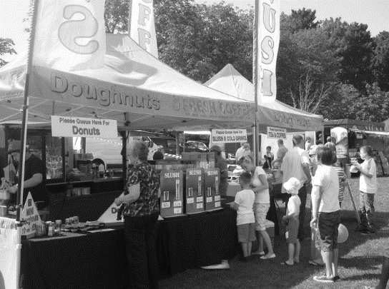

Calculating variable costs (TVC), write the formula in here:

Try the example:

Definition: Revenue
________________________________________________________________________________________________________________________________________________________________________________________________________________________________________________________________________________________________________________________________________
___________________________________________________________________

Examples of Sales Revenue (SR)

Calculating Sales Revenue (SR) write the formula in here:

Try the example:

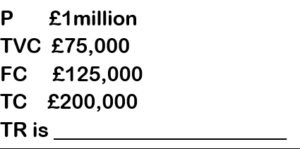

Plenary Quiz

If TR = £21,000, TVC = £7,000 and TC are £11,000
- What are the FC? £__________________
- What is the P? £___________________

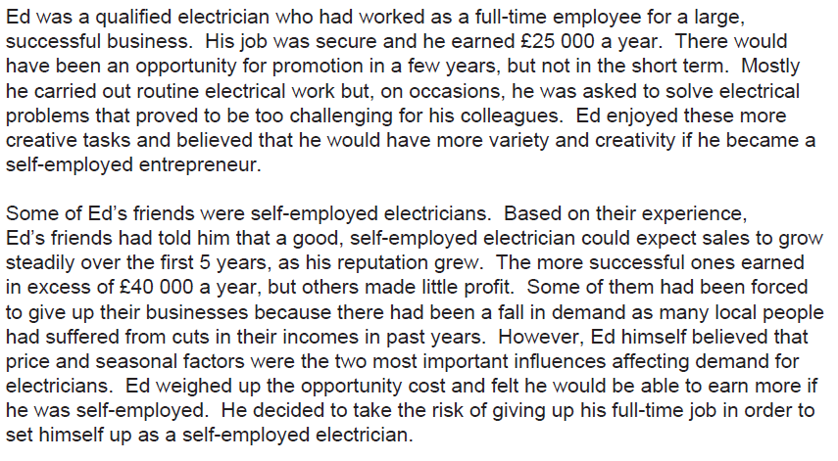

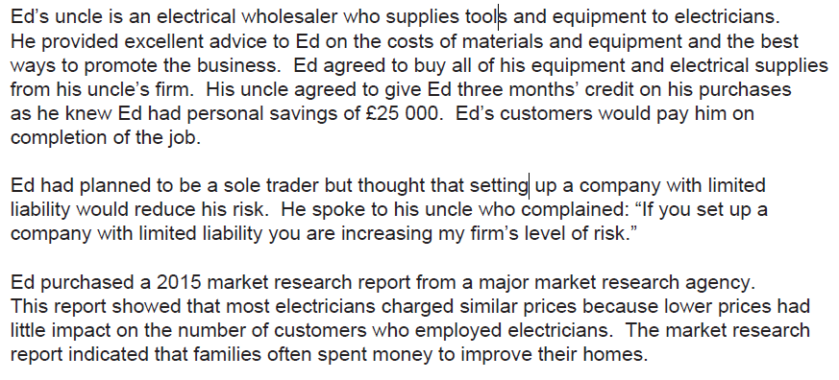

Sample exam question 1

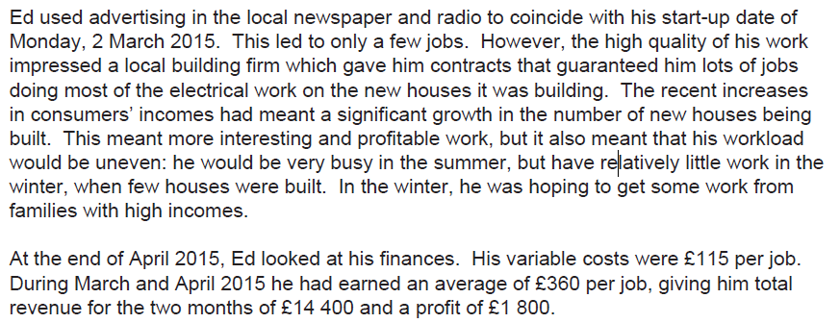

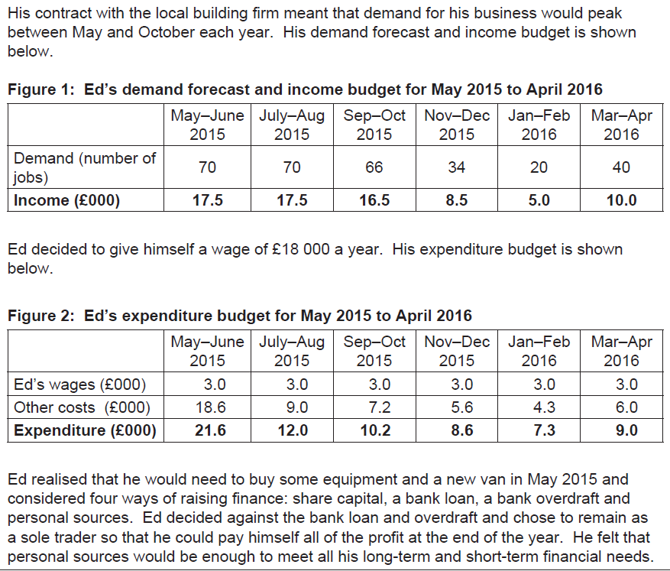

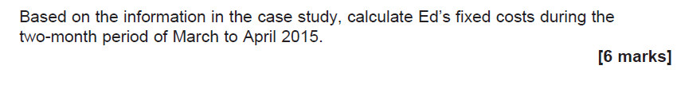

Sample exam question 2

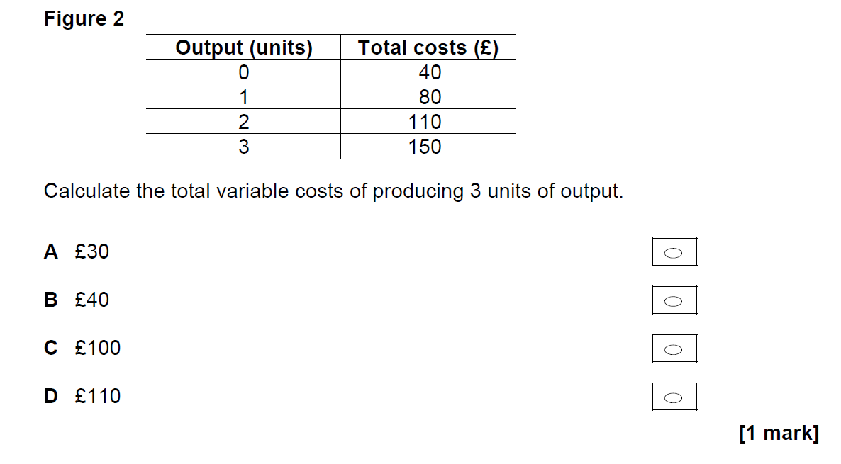

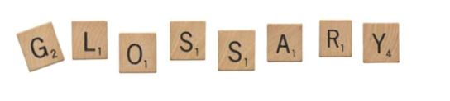

Objective
Social objective
Ethical objective
Revenue
Fixed Costs
Variable Costs
Profit

